Introduction to Autonomous Maintenance (AM)
What is Autonomous Maintenance?
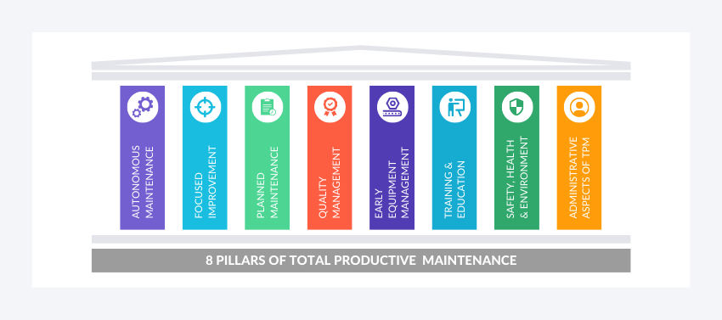
Autonomous maintenance is a maintenance strategy where operators are responsible for routine tasks, such as cleaning, lubricating, and minor maintenance of equipment. The goal is to empower operators to take ownership of their equipment, improving its overall effectiveness and reducing the need for intervention from maintenance teams.
Autonomous Maintenance is part of the 8 TPM pillars and strategy which aims at increasing the performance of a plant in a sustainable way.
AM enhances the knowledge and ownership of the operators to make them able to face more complex problems related to safety, quality, and productivity.
Autonomous maintenance includes any activity performed by the production department that aims at maintaining equipment conditions and is intended to keep the plant operating efficiently to fulfill production plans.
The primary objective of autonomous maintenance is to shift the responsibility for routine maintenance tasks from the maintenance team to the operators. By doing so, the aim is to:
- Improve Equipment Efficiency: Operators are often the first to notice signs of equipment deterioration or inefficiency, allowing for quicker response times and reduced downtime.
- Enhance Equipment Reliability: Regular operator-led maintenance can help identify and address issues early, reducing the likelihood of breakdowns and extending equipment lifespan.
- Empower Operators: Autonomous maintenance empowers operators by involving them in the care and maintenance of the equipment they use, fostering a sense of ownership and pride in their work.
- Reduce Costs: By reducing downtime, extending equipment life, and optimizing maintenance schedules, autonomous maintenance can lead to significant cost savings for organizations.
To achieve AM vision, mission, and objectives, requires a plan involving tools and techniques, and the best use of resources, including people.

7 Steps to AM Implementation
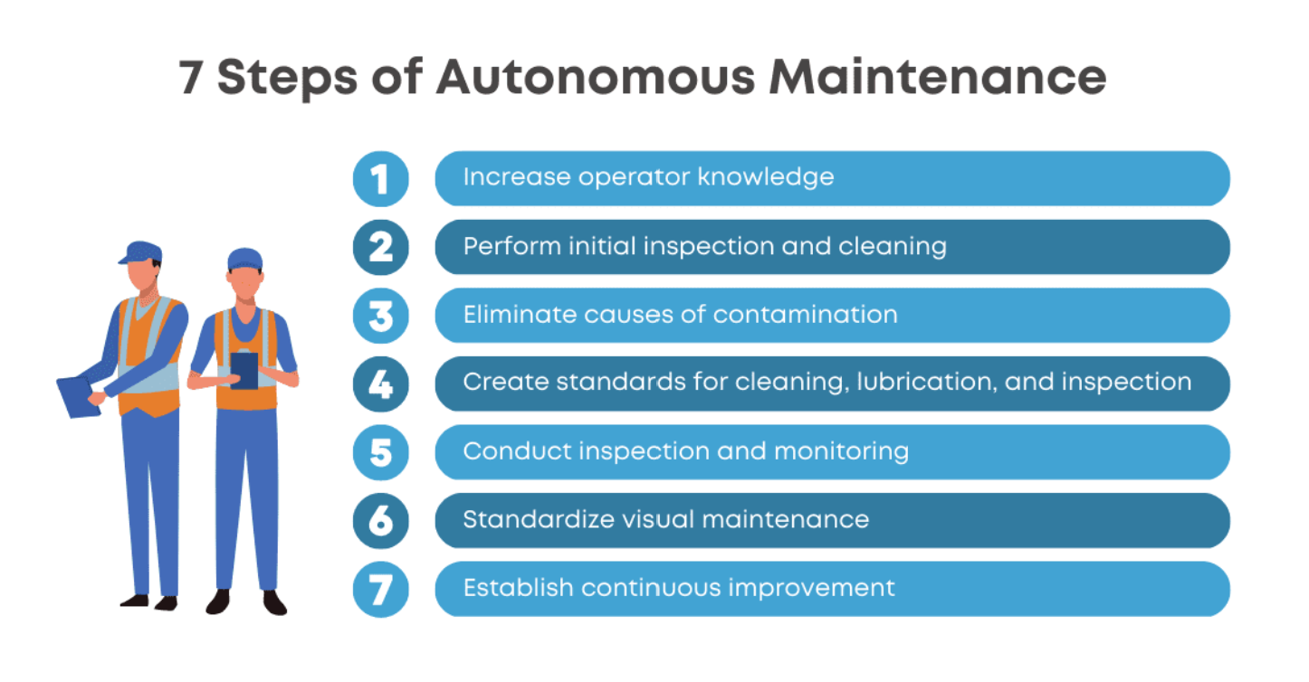
Autonomous maintenance typically consists of seven key steps, which are:
- Increase operator knowledge:

Operators are trained to understand the equipment they work with, including its components, functions, and how to operate and maintain it properly.

Outputs: Training materials, manuals, and certification of operator knowledge.
- Initial cleaning and inspection:

The equipment is thoroughly cleaned to remove dirt, dust, and other contaminants. Simultaneously, operators inspect the equipment for abnormalities or signs of wear.
Outputs: Cleaning logs, inspection checklists, and reports on equipment condition.

- Eliminate causes of contamination:

Identify and eliminate sources of contamination (such as oil leaks, dust, or foreign objects) that can lead to equipment failures.

Outputs: Contamination control plans, and maintenance logs showing contamination prevention measures.

- Set standards for lubrication and inspection:

Establish standards for how and when equipment should be lubricated and inspected to prevent breakdowns.
Outputs: Lubrication schedules, inspection checklists, and procedures for lubrication and inspection.

- Conduct inspection and monitoring:

Regularly inspect and monitor equipment to detect abnormalities or signs of wear early.
Outputs: Inspection reports, monitoring logs, and records of equipment conditions.

- Standardize visual maintenance management:

Use visual tools such as color-coding, labels, and signs to make maintenance procedures and information easily accessible to operators.

Outputs: Visual management boards, standard operating procedures (SOPs), and visual aids for maintenance tasks.

- Establish continuous improvement:

Continuously improve maintenance processes by identifying and implementing better ways to prevent breakdowns and improve efficiency.

Outputs: Improvement plans, records of implemented changes, and metrics showing maintenance performance improvements.

Steps 1 -3 place priority on:
- Abolishing environments that cause accelerated deterioration
- Reversing deterioration
- Establishing equipment maintenance basic equipment conditions.
- Ensuring the operator’s commitment
- Expose and restore hidden defects
- Define routine inspections to prevent future failures
When it comes to inspecting the equipment in the following steps, it is important to understand the 7 categories of sub functional parts.
In the context of autonomous maintenance, the seven categories of sub functional parts refer to the different components or areas of a machine that operators need to inspect and maintain. These categories are:

- Structural Elements: This includes the main body and framework of the machine, such as the frame, casing, and supports.

- Power Transmission Elements: These are the components that transmit power throughout the machine, such as belts, chains, gears, and shafts.

- Moving Parts: These are the parts of the machine that move during operation, such as pistons, slides, and rotating components.

- Control Elements: This includes the components that control the operation of the machine, such as switches, valves, and sensors.

- Auxiliary Elements: These are the components that support the main operation of the machine, such as lubrication systems, cooling systems, and filters.

- Safety Elements: These are the components that ensure the safety of operators and the machine, such as guards, emergency stop buttons, and safety interlocks.

- Operating Environment Elements: This includes factors in the machine's environment that can affect its operation, such as temperature, humidity, and cleanliness.

By categorizing sub functional parts in this way, operators can systematically inspect and maintain each part, ensuring that the machine operates smoothly and efficiently.
The outputs or follow-up items of each step of autonomous maintenance can vary depending on the specific equipment and organization. However, here are some general outputs or follow-up items for each of the seven steps:

- Initial Cleaning:
- Identification of areas requiring further cleaning or inspection.
- Documentation of cleaning procedures and schedules.

- Eliminate Sources of Contamination:
- Identification and elimination of sources of contamination, such as leaks or dust sources.
- Implementation of measures to prevent future contamination.

- Basic Inspection:
- Identification of abnormalities, such as loose bolts or worn parts.
- Documentation of inspection findings and corrective actions.

- Standardization of Cleaning and Inspection:
- Development of standardized cleaning and inspection procedures.
- Training of operators on the new procedures.

- Developing Autonomous Inspection Skills:
- Training of operators on more in-depth inspection techniques.
- Identification of additional inspection points or areas for improvement.

- Implementing General Inspection:
- Regular performance of general inspections by operators.
- Documentation of inspection results and any corrective actions taken.

- Developing Autonomous Maintenance Skills:

- Training of operators on advanced maintenance tasks, such as lubrication or parts replacement.
- Implementation of a system for operators to perform these tasks regularly.
These outputs or follow-up items help ensure that operators are able to effectively maintain equipment and address any issues that may arise, leading to improved equipment reliability and performance.

